

**Software Design Document***
TumorTech AI-powered Brain Tumor Analysis
With Predictive Algorithms :

Submitted by
Bushra Aslam
(F22BINFT1E02075)
7th semester 1E
Submitted to
Ma'am Sara Fareed

Department of Information Technology
The Islamia University of Bahawalpur

Software Design Document

Summary
This Software Design Document (SDD) presents the detailed technical design of the TumorTech AI-Powered Brain Tumor Analysis System, developed to automate the detection and classification of brain tumors using MRI and CT scan images. The document is derived from the approved Software Requirements Specification (SRS) and Final Year Project proposal.
The system leverages deep learning techniques, particularly Convolutional Neural Networks (CNNs), to assist healthcare professionals in early and accurate tumor diagnosis. This document explains the overall system architecture, internal modules, APIs, data model, database schema, UML diagrams, and user interface design. It serves as a reference for developers, evaluators, and stakeholders to understand how the system components interact and how the software will be implemented.

Table of Contents

- Application Architecture
- System Components and APIs
- UML Diagrams
- Database Model Schema
- User Interface Design
- Architecture Diagram

1. Application Architecture
The TumorTech system follows a layered architecture to ensure modularity, scalability, and maintainability. Each layer has a well-defined responsibility and communicates with other layers through RESTful APIs.
1.1 Architectural Layers
1.1.1 Client Layer (Front-End)
Technology: ReactJS, HTML, CSS
Responsibilities:
- Provides an interactive interface for users
- Allows image upload (MRI/CT)
- Displays tumor detection results
- Enables report download in PDF format
Main Components:
- Image Upload Component
- Result Visualization Component
- Report Download Button

1.1.2 API Layer (Back-End)
Technology: FastAPI / Flask
Responsibilities:
- Handles communication between frontend and ML model
- Receives image upload requests
- Sends images for preprocessing and prediction
- Returns analysis results to the frontend
Core API Endpoints:
- /upload-image
- /process-image
- /generate-report
- /download-report

1.1.3 Machine Learning Layer
Technology: TensorFlow / PyTorch
Responsibilities:
- Image preprocessing (resizing, normalization)
- Tumor detection and classification
- Confidence score generation
The CNN-based deep learning model analyzes the medical images and identifies tumor regions.

1.1.4 Data Layer
Technology: MongoDB / PostgreSQL
Responsibilities:
- Stores user information
- Saves uploaded images
- Maintains tumor detection results
- Stores generated reports

2. System Components and APIs
2.1 Image Upload Module
- Accepts MRI/CT images (PNG, JPEG, DICOM)
- Validates file size and format
- Ensures secure file transmission
2.2 Image Preprocessing Module
- Image normalization
- Noise reduction
- Resizing for model compatibility
2.3 Tumor Detection Module
- Uses a pre-trained CNN model
- Detects tumor presence
- Generates confidence score
2.4 Report Generation Module
- Compiles detection results
- Generates downloadable PDF report
2.5 REST API Module
- Manages frontend-backend communication
- Ensures modular and scalable architecture

3. UML Diagrams
3.1 Use Case Diagram
Actors:
- User
Main Use Cases:
- Upload Image
- Preprocess Image
- Tumor Detection
- Generate Report
- Download Report
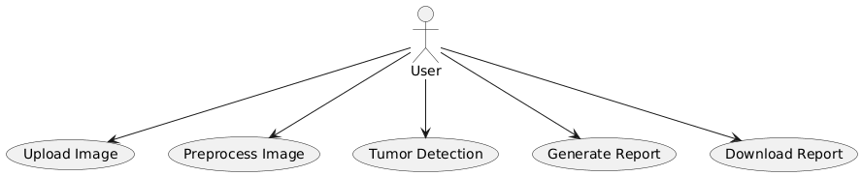

3.2 Class Diagram
Classes and Responsibilities:
- User
  - Attributes: username, email, contactNumber
  - Methods: uploadImage(), downloadReport()
- Image
  - Attributes: imageID, imagePath, status
  - Methods: validateImage(), normalizeImage()
- TumorModel
  - Attributes: modelID, modelVersion, confidenceScore
  - Methods: detectTumor(), analyzeImage()
- Report
  - Attributes: reportID, generateDate, reportPath
  - Methods: generateReport(), fetchAnalysis()
- API
  - Attributes: apiEndpoint, apiKey
  - Methods: processImage(), sendImage()
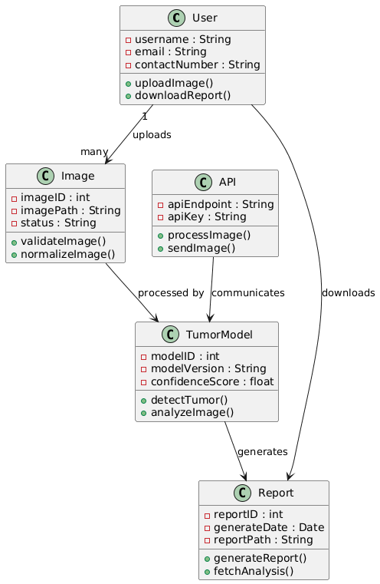

3.3 Sequence Diagram
Flow:
- User uploads image via UI
- Backend validates and preprocesses image
- API sends image to tumor detection model
- Model analyzes image and returns results
- Report is generated
- User downloads report
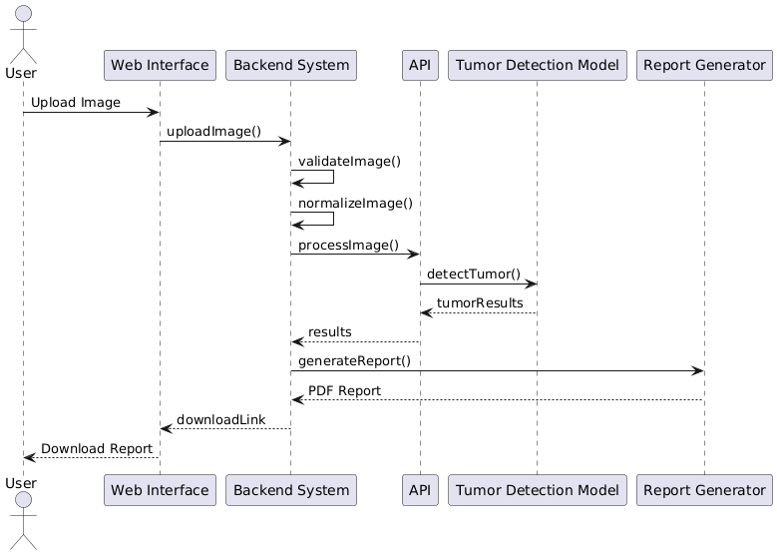

4. Database Model Schema for Brain Tumor Detection System
This schema is tailored for saving images, processing them, and storing the results. It includes the essential tables for your requirements.

Image
Imageid INT
Filename Varchar
Filepath Varchar
uploadDate dateTime
Status ENum

Tumor detection Result
Resulted INT
Imageid INT
Tumordetected Bolean
Confidence score Decimal
Detection date DateTime

Figure : Database Schema for Brain Tumor Detection

5. User Interface Design
5.1 Design Philosophy
- Clean and minimal layout
- Medical-oriented color scheme
- Simple navigation
- Responsive design for desktop and tablet screens

5.2 Screens and Controls
5.2.1 Login Screen
- Textboxes: Email, Password
- Button: Login
5.2.2 Image Upload Screen
- File Upload Control
- Button: Upload Image
- Input Constraint: Valid image formats only
5.2.3 Result Screen
- Tumor detection result display
- Confidence score
- Button: Generate Report
5.2.4 Report Download Screen
- Button: Download PDF Report

5.3 Input Constraints
- Only MRI/CT images allowed
- Maximum file size enforced
- Secure input handling

6.Architectural Diagram for Brain Tumor Detection System

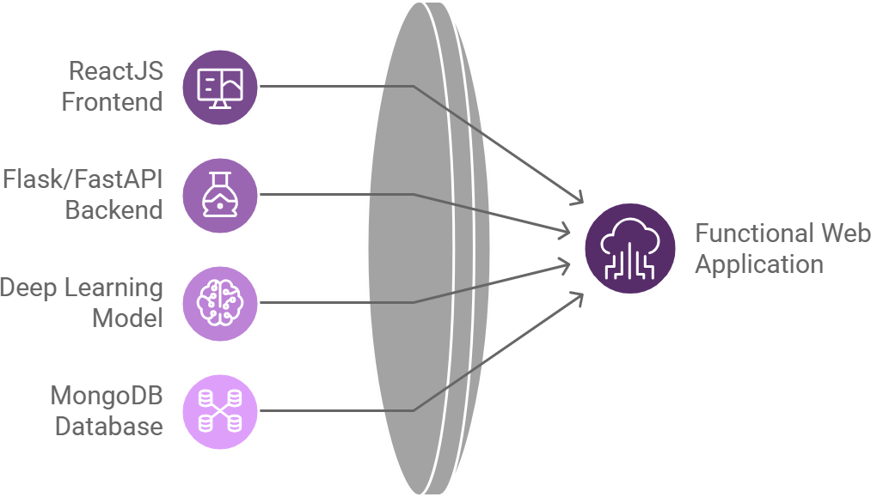

User Interface (UI) Layer
  - Purpose: Allows users to upload MRI/CT images and download the result/report.

Components:
    - Web application or mobile app interface.
    - Provides options for image upload and report download.
  - Technology: React.js, HTML, CSS.

Application Layer
  - Purpose: Handles application logic, API communication, and user requests.

Components:
    - REST API for communication between frontend and backend.
    - Image preprocessing and validation.
  - Technology: Flask, FastAPI, or similar frameworks.

Processing Layer
  - Purpose: Processes images using AI models and generates results.

Components:
    - Deep Learning model (e.g., TensorFlow, PyTorch).
    - Tumor detection logic.
  - Technology: Google Colab, trained neural networks.

Data Layer
  - Purpose: Stores uploaded images and their associated results.

Components:
    - Database for image metadata and results.
    - File storage for images and reports.
  - Technology: MySQL, SQLite, or MongoDB.

Output Layer
  - Purpose: Provides the final result to the user.

Components:
PDF report generation and download functionality

